



Implementation of End-to-End Set Operations
LAB MANUAL

Disclaimer: The content is curated from online/offline resources and used for educational purpose only
Implementation of End-to-End Set Operations
Objective:
- Learn how to create sets, add/remove elements, and understand the uniqueness of elements in sets.
- Perform union operations to combine elements from two sets.
- Use intersection to find common elements between sets.
- Find elements present in one set but not in another using difference.
- Use symmetric difference to find elements that are unique to each set.
- Check whether a set is a subset or superset of another set.
- Use the in keyword to check if an element is a member of a set.
- Apply sets to remove duplicate elements from a list or any other collection.
- Understand how to use set comprehension to generate sets based on conditions.
- Use set methods like add(), update(), remove(), discard(), and pop() to modify sets.
Problem Statement:
- In this problem , you will explore how to perform various set operations using Python. Sets are a built-in data type in Python used to store collections of unique elements. The objective is to understand and apply different methods and techniques to manipulate sets, including operations like union, intersection, difference, symmetric difference, and set comprehension.
Equipment Required:
- Install VS Code - https://code.visualstudio.com/download
- Download Python Installer File - https://www.python.org/downloads/
Prerequisites:
- Basic Computer Skills - Anyone starting to learn computer programming needs basic computer skills.
- Basics of control statements

Procedure:

Task 1: Implementation of Creating Sets
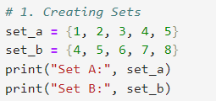
Output:
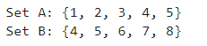
Task 2: Implementation of Adding and Removing Elements in a Set
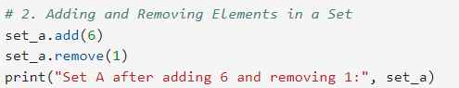
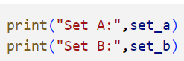
Output:
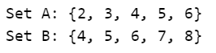
Task 3: Implementation of Union of Sets
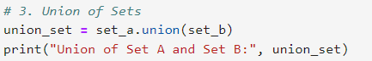
Output:
Task 4: Implementation of Intersection of Sets
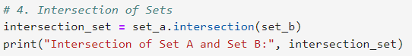
Output:
Task 5: Implementation of Difference of Sets
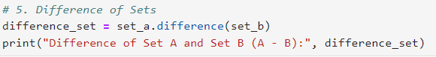
Output:
Task 6: Implementation of Symmetric Difference of Sets
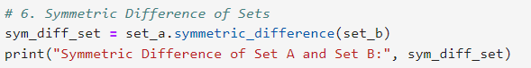
Output:
Task 7: Implementation of Subset and Superset Testing
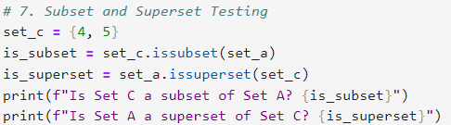
Output:
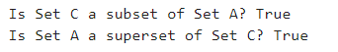
Task 8: Implementation of Set Membership Testing
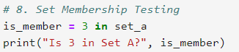
Output:
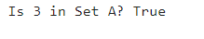
Task 9: Implementation of Removing Duplicates Using Sets
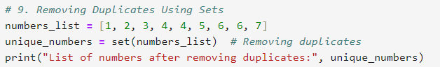
Output:
Task 10: Implementation of Set Comprehension
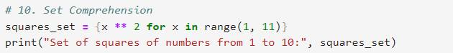
Output:
Task 11: Implementation of Clearing a Set
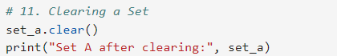
Output:
